**PROGNOSTIC MODELING**

**A Real-Time Research Project Report**

***Submitted to***



**Jawaharlal Nehru Technological University**

Hyderabad

*In partial fulfillment of the requirements for the award of the degree of*

**BACHELOR OF TECHNOLOGY**

**in**

**ARTIFICIAL INTELLIGENCE & MACHINE LEARNING**

By

**Name:G.Ashwitha (23VE1A6613)**

**NAME:K.Srinidhi(23VE1A6622)**

**NAME:T.Siri Meghana(23VE1A6652)**

# Under the Guidance of

**K.Shivaram Reddy Assistant Professor**



**DEPARTMENT OF CSE (ARTIFICIAL INTELLIGENCE & MACHINE LEARNING)**

Approved by AICTE, New Delhi | Affiliated to JNTUH, Hyderabad | Accredited by NAAC “A” Grade & NBA| Hyderabad | PIN: 500068

# Certificate

This is to certify that the Real-Time Research Project Report on***“Prognostic Modeling***” submitted by **G.Ashwitha ,K.Srinidhi, T.Siri Meghana** bearing Hall Ticket No’s.**23VE1A6613, 23VE1A6622, 23VE1A6652**in partial fulfillment of the requirements for the award of the degree of **Bachelor of Technology** in **Artificial Intelligence & Machine Learning** from Jawaharlal Nehru Technological University, Kukatpally, Hyderabad for the academic year 2024-25 is a record of bonafide work carried out by him / her under our guidance and Supervision.

|  |  |
| --- | --- |
| **Internal Guide** | **Head of the Department** |
| **K.Shivaram Reddy** | **Dr. A. Swathi** |

**Asst. Professor**

**Project Coordinator**



**DEPARTMENT OF CSE (ARTIFICIAL INTELLIGENCE & MACHINE LEARNING)**

Approved by AICTE, New Delhi | Affiliated to JNTUH, Hyderabad | Accredited by NAAC “A” Grade & NBA| Hyderabad | PIN: 500068

## DECLARATION

We **G.Ashwitha, K.Srinidhi, T.Siri Meghana,** bearing Roll No’s **23VE1A6613, 23VE1A6622, 23VE1A6652**hereby declare that the Project titled "***Prognostic Modeling***” done by us under the guidance of **K.shivaram** , which is submitted in the partial fulfillment of the requirement for the award of the B.Tech degree in **Artificial Intelligence & Machine Learning** at **Sreyas Institute of Engineering & Technology** for Jawaharlal Nehru

Technological University, Hyderabad is our original work.

|  |  |
| --- | --- |
| **G.Ashwitha** | **23VE1A6613** |
| **K.Srinidhi** | **23VE1A6622** |
| **T.Siri Meghana** | **23VE1A6652** |

### ACKNOWLEDGEMENT

The successful completion of any task would be incomplete without mention of the people who made it possible through their guidance and encouragement crowns all the efforts with success.

we owe everything to the **Department Faculty, Principal** and the **Management** who made my term at Sreyas Institute of Engineering and Technology a stepping stone for my career. I treasure every moment I have spent in college.

Last but not the least, my heartiest gratitude to my parents and friends for their continuous encouragement and blessings. Without their support, this work would not have been possible.

**G.Ashwitha 23VE1A6613 K.Srinidhi 23VE1A6622**

**T.Siri Meghana 23VE1A6652**

## CHAPTERSINDEX

Abstract………………………………………………………….……………………….1

**CHAPTER 1. INTRODUCTION………………………………………………………2**

1.1 Problem statement………………………………………………………………….…4

**CHAPTER 2. LITERATURE SURVEY……………………..………..………………5**

2.1 Existing System..……...…………................................................................................5

2.2 Proposed System…...................................................................................................…5

**CHAPTER 3. SYSTEM DESIGN….………………………………………………….7**

3.1 Importance of Design………………………………………………………………...7

3.2 System Architecture………………………………………………………………….7

3.3Functional Requirements……………………………………………………………..9

**CHAPTER 4. IMPLEMENTATION…………………………………………………11**

4.1 Module Description………………………………………………………………….11

4.2 Module Components…………………………………………………………………14

4.2.1 Dataset (If any)…………………………………………………………….14

4.2.2 Data Analysis and Visualization...…………………………………………14

4.2.3 Web Interface………………………………………………………………15

4.3 Sample Code...……………………………………………………………….15

**CHAPTER 5. RESULTS………………………………………………………….……17**

**CHAPTER 6. CONCLUSION AND FUTURE SCOPE……………………………..19**

**CHAPTER 7. REFERENCES…………………………………………………………23**

**PUBLICATION CERTIFICATE..……………………………………………………26**

**LIST OF FIGURES**

|  |  |  |  |
| --- | --- | --- | --- |
| **Fig.No** |  | **Name of Figures** | **Page No** |
| **Fig.1** | Work flow of model |  | 9 |
| **Fig.2** | Components |  | 14 |
| **Fig.3** | Sample code |  | 16 |
| **Fig.4** | Results |  | 17 |
| **Fig.5** | Iris feature graphs |  | 20 |

**ABSTRACT:**

Prognostic models need to forecast forthcoming consequences and aid in clinical decision-making. In this study, our purpose was to establish and authenticate a forecast model for [outcome] among [condition or attributes]. Cardiovascular disease still has the biggest toll on people in the entire world and creates an imperative requirement for novel non-invasive diagnostic modalities. Technical developments based on artificial intelligence as well as the evolution in imaging have shown attention toward predication of cardiac disease using eye biomarkers. The eyes, and in particular the retina, give us a unique glimpse of the vascular system, and thus a valuable glimpse of cardiovascular health. Alterations of retinal vasculature, for example narrowing, hemorrhage, or microaneurysm, could be indicative of systemic disease, for instance hypertension and atherosclerosis, two principal risk factors for coronary heart disease. This research examines the possibility of applying eye pictures, specifically fundus pictures, and machine learning algorithms to the prediction of heart disease. Through the use of the images of the eyes and related cardiovascular health information in tagged data sets for training the models, the system is able to detect and recognize the extremely subtle patterns in the images which are indicative of heart disease. Integration with deep learning models leads to highly accurate early detection and, feasibly, the intervention of the physician in a timely manner. The method offers an affordable, accessible, and non-invasive screening method, particularly in resource-poor settings. The study puts into focus ocular diagnostics as an aid to cardiovascular disease risk prediction and opens doors to future cross-disciplinary studies in cardiology and ophthalmology.

### CHAPTER1

#### INTRODUCTION

Cardiovascular disease is one of the major causes of death worldwide, with millions of deaths occurring each year. Early detection and preventive management are vital in alleviating the burden of cardiovascular diseases, but conventional diagnostic modalities such as electrocardiograms (ECGs), blood tests, and angiography are invasive, expensive, and less accessible in low-resource settings. This has prompted the medical community to look for newer, non-invasive tools of early and reliable diagnosis. One of the potential techniques is predicting heart disease through the eyes, and this can be done in particular through retinal examination. The retina located at the back of the eye contains a very tight plexus of microscopic blood vessels, and these may reflect the vascular and systemic health of an individual. Because the eye offers a direct view of body microcirculation, it constitutes a perfect window to cardiovascular performance, and from it, physicians can detect subtle evidence of incipient hypertension, diabetes, and atherosclerosis—chief predictors of heart disease. The eye's retinal vessels' pathology such as narrow blood vessels, hemorrhages, microaneurysms, and arteriovenous nicking have also been linked with cardiovascular disease that provide valuable risk-predicting biomarkers.

With the advent of more advanced imaging techniques, such as optical coherence tomography (OCT) and fundus photography, high-resolution images of the retina can be taken quickly and comfortably. These images can identify subtle patterns of vascular change that may precede the onset of clinical presentation of heart disease before they occur. But to interpret such images is a slow and expert process. In pursuit of this goal, researchers have turned to machine learning (ML) and artificial intelligence (AI) to automate the processing of retinal photographs. Deep learning models, especially convolutional neural networks (CNNs), have been shown to be extremely reliable at detecting cardiovascular risk factors such as high blood pressure, cholesterol, and even predicting oncoming cardiac events directly from retinal scans. These models are learned on vast datasets with both retinal images and related health records, allowing them to learn complex patterns and correlations that may not be easily visible to human observers. The addition of patient data such as age, gender, medical history, and lifestyle factors to retinal imaging increases the predictive power of these AI systems even more.

One of the strongest benefits to using the eye when predicting heart disease is that it is not an invasive technique. Unlike other tests in medical imaging, such as having blood drawn, injections done, or catheters inserted within your body, retinal photography is painless, innocuous, and uncomplicated. In addition, as retinal cameras are now portable and affordable—and with phone-mount models available—eye-based screening can even be done in underserved or rural communities, making it a highly accessible early detection strategy. This is especially useful in low- and middle-income countries where specialist cardiovascular diagnostics may not be easily available. Besides, retinal screening can be integrated into routine eye examination or health check-up, thereby becoming available to a larger population and detecting high-risk individuals even before they develop symptoms or complications. Recent studies in this direction continue to produce encouraging results. Companies such as Google Health, alongside upscale hospitals, have shown that cardiovascular risk factors like age, sex, smoking, and even risk of a fatal cardiac event are possible to forecast using AI models.

Clinical trials have established the truth that specific retinal characteristics are highly correlated with risk of heart disease, providing the scientific basis for the method. But even as technology has been making giant leaps forward, there are still problems to be solved. To take just one example, light, movements of the eye, or indeed other eye disease like cataract or diabetic retinopathy can distort the quality of images from the retina. Moreover, AI algorithms need huge, representative, and high-quality datasets before they can become accurate, objective, and portable across a vast number of heterogeneous populations.

Ethics are also at the center while developing and implementing AI-based diagnostic technology. Data privacy, bias in algorithms, and transparency of AI predictions must be addressed to build clinician and patient trust. AI must be used to support diagnosis but not substitute the clinician but support the clinician and facilitate decision support. There needs to be interdisciplinarity among ophthalmologists, cardiologists, data scientists, and public health experts to develop effective, scalable, and ethically responsible systems for predicting heart disease.

In essence, eye imaging to forecast heart disease is a paradigm shift in cardiovascular risk stratification. Leveraging the structural and vascular makeup of the retina and the power of artificial intelligence, it is a low-cost, non-invasive, and readily accessible early detection method. With changing science and technology, eye prediction of heart disease can have high prospects to be part of prevention in a broader way, lessening global rates of heart disease and saving millions of lives via the mechanism of early treatment.

**1.1Problem Statement:**

Heart disease remains the largest killer of all ages around the world, and scientists and Physicians are seeking to develop new, non-invasive, yet efficient ways to detect it Early and assess its risk. Possibly one of the most intriguing and exciting applications Of the latest findings has been the application of eye scanning, specifically retinal Scanning, in predicting heart disease. This cross-disciplinary methodology takes Advantage of the intimate relationship between cardiovascular health and ocular Markers, in this case, the retinal vasculature, which are mirrors of systemic vascular Health. Through the convergence of ophthalmology, cardiology, and artificial Intelligence, this method promises a new era in preventive and precision medicine.

The eye, and more specifically, the retina, provides a glimpse of the body’s circulatory System. Microvasculature is present in the retina, which is highly comparable to the Heart’s blood vessels. Vessel diameter, shape, branching morphology, or the presence Of microaneurysms and hemorrhage affecting retinal vessels can signal underlying Cardiovascular conditions like hypertension, atherosclerosis, and diabetes — all strong cardiovascular risk factors. Since the retinal signs can appear earlier than clinical manifestation of heart disease, eye imaging provides a lead time indicator for Cardiovascular disease. That is most beneficial because routine diagnostic tests such as ECGs, stress tests, and angiograms are only run on a routine basis after symptoms Have arisen or in only risk groups.

This computerized method has a number of advantages. It is painless, rapid, and Inexpensive relative to most standard diagnostic equipment. It also promises to Increase access to cardiovascular screening, especially in rural or underserved Communities where specialist cardiac equipment and personnel are not necessarily Present. A routine eye examination at an optometrist or ophthalmologist might be a Cardiovascular examination, yielding combined information regarding a patient’s Overall health and allowing for earlier intervention.

#### CHAPTER2 LITERATURE SURVEY

**2.1 Existing System:**

The existing system for heart disease prediction is a non-invasive, AI-powered diagnostic platform that utilizes retinal fundus images to assess cardiovascular risk. By leveraging advanced imaging techniques and deep learning models—primarily convolutional neural networks (CNNs)—the system analyzes subtle vascular features in the retina, such as vessel tortuosity, narrowing, and hemorrhages, which are known indicators of cardiovascular conditions like hypertension and atherosclerosis. The process begins with data acquisition, where retinal images and relevant patient metadata (e.g., age, gender, medical history) are collected. These images undergo preprocessing steps including normalization, contrast enhancement, and noise filtering to ensure quality input for the model. Feature extraction is then performed to isolate important anatomical structures, and clinical data is fused with the image features to enhance predictive accuracy. The trained CNN model classifies the images, providing a binary (disease/no disease) or probabilistic risk score. The output includes visual aids such as heatmaps and reports, aiding clinicians in interpretation. Designed with accessibility in mind, the system is particularly beneficial in resource-limited settings, offering a low-cost, rapid, and scalable solution for early detection of heart disease, though it requires large, high-quality datasets and ethical considerations in deployment.

**2.2 Proposed System:**

Retinal imagingThe model tried here tries to forecast heart disease using deep learning algorithms to analyze retinal photographs. The novel method provides a simple, inexpensive, and non-invasive means of early cardiovascular risk estimation. The method is on the medical concept that the retina provides a map of the body's circulation and retinal vessel changes can forecast system disease like hypertension, diabetes, and cardiovascular disease. With the aid of artificial intelligence (AI) image analysis of the retina, the program attempts to identify minute changes and forecast subsequent cardiovascular complications before they occur clinically**.**

The system is dependent on some fundamentals. The retinal fundus photographs are first taken using typical fundus cameras or retina imaging devices based on smartphones. They then pass through a preprocessing phase that involves various processes including contrast stretching, noise elimination, and blood vessel segmentation. The phase is instrumental in the image improvement as well as making them ready for apt feature extraction by the AI model.

At the heart of the system lies a Convolutional Neural Network (CNN), one of the most powerful deep learning architectures for image classification and pattern recognition tasks.

The CNN is trained on a big set of labeled retinal images and patient cardiovascular data, i.e., history of heart disease, blood pressure readings, and cholesterol levels. By training, the model will learn to identify patterns and anomalies in the retinal morphology—e.g., narrowing, tortuosity, or anomalous branching of vessels—that are associated with heart disease. Once trained, the model will be able to predict the presence or degree of risk of heart disease from new retinal images. user interface (UI) is integrated within the platform so that clinicians and technicians can upload images easily and receive diagnostic input. Output can be a risk score or classification of low, moderate, or high risk of cardiovascular issues. For better utilization, the UI can also mark trouble areas on the image, such as abnormal blood vessel morphology.

This system is particularly valuable in rural or resource-constrained settings, where expert cardiologists or high-end diagnostic tools are not readily available. Using standard retinal cameras and artificial intelligence, the system can be used as a primary screening system to help healthcare staff identify patients who are at risk and need a more thorough examination.In addition to its diagnostic purpose, the system also offers data storage and analysis functions, which allow ongoing research and model development. Every piece of patient information is handled with security and privacy protocols to allow conformity to medical data standards.In summary, the proposed system will most likely transform routine eye checks into beneficial screening procedures for cardiovascular disease. It offers a quicker, safer, and more convenient method of early detection, paving the way for prevention and reducing the burden on health systems.

#### CHAPTER3 SYSTEM DESIGN

**3.1 Importance Of Design:**

The design of the heart disease prediction system is crucial because it directly impacts the system’s accuracy, usability, scalability, and accessibility. A well-structured design ensures seamless integration of multiple components—data acquisition, preprocessing, feature extraction, model prediction, and result visualization—into a coherent workflow. It enables the system to process diverse and high-volume retinal data efficiently while maintaining performance and accuracy. The modular and hierarchical architecture supports scalability and easy upgrades, such as incorporating new algorithms or expanding datasets. Importantly, a user-centric interface design enhances usability for healthcare professionals by simplifying image uploads, interpreting results, and guiding clinical decisions through visual aids like heatmaps. From a technical perspective, design considerations also address computational efficiency, especially in lowresource environments, and incorporate secure data handling practices to protect patient privacy. Ultimately, a robust system design ensures that the technology can be reliably deployed in realworld medical settings, including rural and underserved areas, making early heart disease screening both practical and impactful.

**3.2 System Architecture:**

The design of the retinal imaging system predictive model for heart disease is intended to allow smooth data transfer, strong analysis, and easy availability for clinical use. It is designed with a series of interdependent modules that are intended to carry out a specific task in the prediction pipeline. It is hierarchical and modular in design and therefore scalability, flexibility, and ease of integration are possible.

1**.Input Stage:** Command Processing & Data Acquisition

Data Acquisition phase, where patient metadata and retinal images are obtained. They are retinal images, typically through a fundus camera, and patient data relevant to analysis such as medical history, sex, lifestyle information, and age. They are crucial as they form the basis for adequate and specific analysis.

2.**Preprocessing Stage**:In this, the images are made to be of similar quality and shape. Contrast enhancement, resizing, noise filtering, and blood vessel segmentation are some of the operations used to remove redundant information and highlight the vascular structures of the retina, of most importance to cardiovascular health.

3. **Feature Extraction:** feature Extraction module, in which vascular features including vessel diameter, turn or tortuosity, bifurcations, and other morphological patterns are extracted. Features have been shown to be correlated with numerous cardiovascular risk factors and disease, and the accurate extraction of these features is therefore required for the next processing stage.

4.**Data fusion:**Data Fusion approach is implemented, combining image-based outcomes with clinical data. Data Fusion employs the model input by balancing medical parameters (for example, cholesterol value or blood pressure) against visual data and thereby enhancing the predictability accuracy. The data set that are combined are introduced into the Machine Learning Model, which is typically a Convolutional Neural Network (CNN) trained to detect patternsin features of the retinal related to cardiovascular disease.

1. **Machine Learning Model**: Machine Learning Model, in the form of a Convolutional Neural Network (CNN), was trained to recognize patterns of retinal characteristics relating to heart disease.
2. **Post-Prediction Analysis & Reporting:post-Prediction phase**, where analysis is translated and results made human-readable. It includes risk scores, diagnosis classification (e.g., high, moderate, or low risk), and other recommendations. It enables efficient presentation of intricate AI results to clinicians.
3. **Visualization and reporting:** Visualization and Reporting module, which produces visualization like highlighted vessel anomalies, graph, and summary report. It interprets the output of the model ahead of them and cross-validated with the conventional method whenever necessary.

**Output Stage:** Healthcare Output The output is displayed to the end-user, i.e., either healthcare provider or patient, using a secure interface. This type of output yields early diagnosis and treatment through early clinical decision-making, preventive intervention, or referral for additional cardiac investigation.

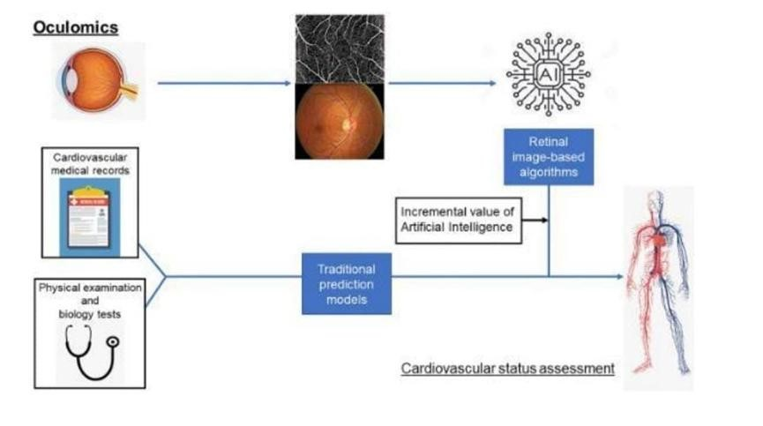

Fig 1: Detail Workflow of model

3.3 **Functional Requirements:**

Image Upload:

* + - Users (clinicians or technicians) can upload high-resolution retinal fundus images.
    - Option to input patient metadata (e.g., age, gender, medical history).

Image Preprocessing:

* + - Automatic operations such as resizing, contrast enhancement, and noise filtering.
    - Standardizes image quality for consistent analysis.

Feature Segmentation:

* + - Automatic detection and segmentation of key retinal structures (e.g., blood vessels, optic disc).

Disease Prediction:

* + - Use of trained machine learning/deep learning models (e.g., CNNs) to assess cardiovascular risk.
    - Output can be:

Binary (e.g., disease/no disease)

Probabilistic (e.g., 72% risk of heart disease) Result Visualization:

* + - Display of results along with visual aids like:
    - Heatmaps
    - Saliency maps
    - Risk level indicators (Low/Moderate/High) Data Logging & History Tracking:
    - Storage of predictions and associated patient data for longitudinal analysis.

User Access & Role Management:

* + - Secure login system with role-based access control to protect sensitive data.

Reporting & Export:

* + - Generation of diagnostic reports that can be printed or exported for recordkeeping or referrals.

### CHAPTER4 IMPLEMENTATION

**4.1 Module Description:**

1. **Image Acquisition Module**

Purpose: Collects high-resolution retinal fundus images and patient metadata.

Functionality: Accepts image input from fundus cameras or mobile imaging devices and gathers data like age, gender, and medical history.

1. **Preprocessing Module**

Purpose: Enhances image quality and standardizes inputs.

Functionality: Image resizing, Contrast adjustment, Noise removal, Blood vessel segmentation Importance: Ensures clean and consistent data for accurate model analysis.

1. **Feature Extraction Module:**

Purpose: Identifies and extracts relevant retinal features.

Functionality:

Detects vessel diameter, tortuosity, bifurcations, lesions, and optic disc.

Uses algorithms like Histogram of Oriented Gradients (HOG) for pattern analysis.

Output: Structured feature set for model input.

1. **Data Fusion Module**

Purpose: Enhances prediction accuracy by integrating clinical and image-based data.

Functionality: Merges extracted retinal features with patient clinical data (e.g., blood pressure, cholesterol) for a holistic risk profile.

1. **Prediction Module (Machine Learning Model)** Purpose: Performs heart disease risk prediction.

Functionality:

CNN processes retinal image features.

Classifies risk as:

Binary: Disease/No Disease

Probabilistic: % risk score

Output: Predicted cardiovascular risk level.

1. **Post-Prediction & Visualization Module**

Purpose: Interprets and presents prediction results.

Functionality:

Generates heatmaps/saliency maps.

Highlights areas of concern.

Provides risk interpretation for clinical decision support.

1. **Reporting & History Module**

Purpose: Stores and retrieves prediction results.

Functionality:

Maintains patient history

Generates diagnostic and progress reports over time Supports comparative analysis.

1. **User Management Module** Purpose: Manages secure user access.

Functionality:

Login/authentication system

Role-based access control (e.g., admin, doctor, technician) Ensures data privacy and system integrity.

**4.2 Module Components:**

1. **Image Acquisition Module Components:**

* Fundus camera or smartphone-based imaging device
* Image upload interface
* Patient data input form (age, gender, history) **2. Preprocessing Module Components:**
* Image normalization tools
* Contrast enhancement filters
* Noise reduction algorithms (e.g., Gaussian filters)Vessel segmentation algorithms. **3. Feature Extraction Module Components:**
* Morphological analyzers for retinal vessels
* Histogram of Oriented Gradients (HOG) for pattern extraction
* Optic disc and lesion detection submodules

**4. Data Fusion Module Components:**

* Clinical data parser (e.g., BP, cholesterol)
* Image-clinical data integrator • Feature normalization layer **5. Prediction Module (CNN-based) Components:**
* Convolutional layers (for feature detection)
* Pooling layers (for dimensionality reduction)
* Fully connected layers (for classification)
* Softmax or sigmoid layer (for output probability)
* Pre-trained weights and model loader **6. Post-Prediction & Visualization Module Components:**
* Risk score generator
* Heatmap/saliency map visualizer
* Interpretation assistant (explanation texts or symbols)

1. **Reporting & History Module Components:**
   * + - Prediction result logger
       - Patient record database
       - Report generation engine (PDF/export options)
       - Timeline viewer for patient history
2. **User Management Module Components:**
   * Authentication system (login, password encryption)
   * Role-based access controller (admin, clinician, technician Activity logger
   * Secure data storage protocols

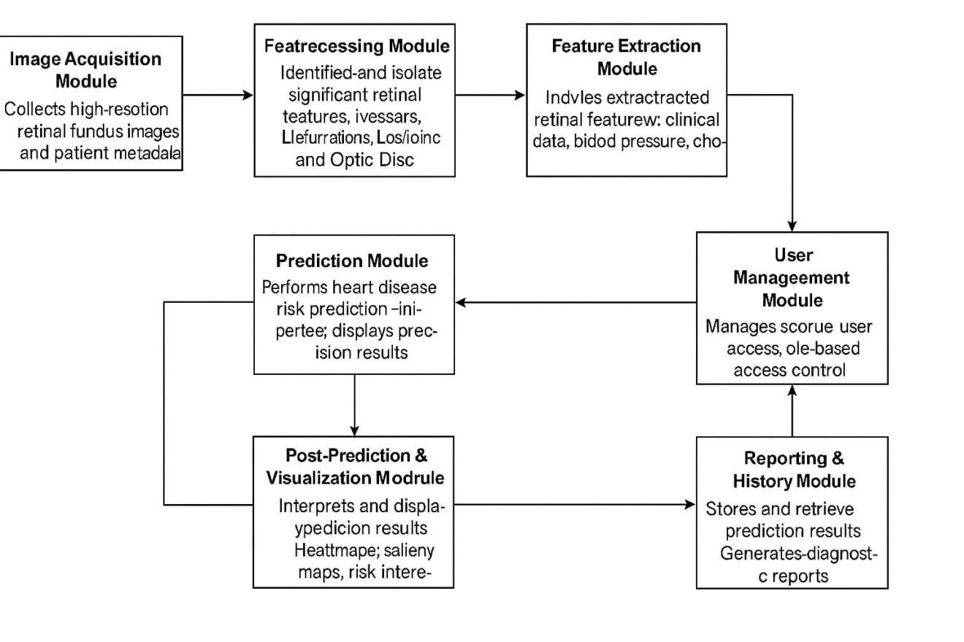

Fig 2: Components

* + 1. **Dataset**

Source: Retinal fundus images from public databases or clinical repositories.

Content: Images and associated patient data (age, gender, medical conditions).

Purpose: Provide training and evaluation material for machine learning models.

* + 1. **Data Analysis and Visualization**

Preprocessing Techniques: Includes contrast enhancement, noise removal, and resizing of images.

Feature Extraction: Focused on detecting key retinal features like:

Vessel diameter

Tortuosity

Hemorrhages or microaneurysms

Model: A Convolutional Neural Network (CNN) processes the images to identify hidden features correlated with cardiovascular disease.

Visualization Tools:

Heatmaps

Risk scores

Diagnostic overlays on the retinal image

These visualizations support interpretability for clinicians, showing which regions of the retina influenced the diagnosis.

**4.2.3 Web Interface**

The web interface serves as the user interaction point for the system. Key features include:

Image Upload: Users (clinicians or technicians) can upload retinal images.

Prediction Output: The interface displays the heart disease risk score (e.g., “Low”, “Moderate”, “High”).

Visual Explanation: It provides annotated images highlighting problematic areas. Secure Access: Role-based login ensures that only authorized personnel access sensitive data.

This interface is designed to be lightweight, responsive, and intuitive for use in hospitals, rural clinics, and mobile health units.

**4.3 Sample Code:**

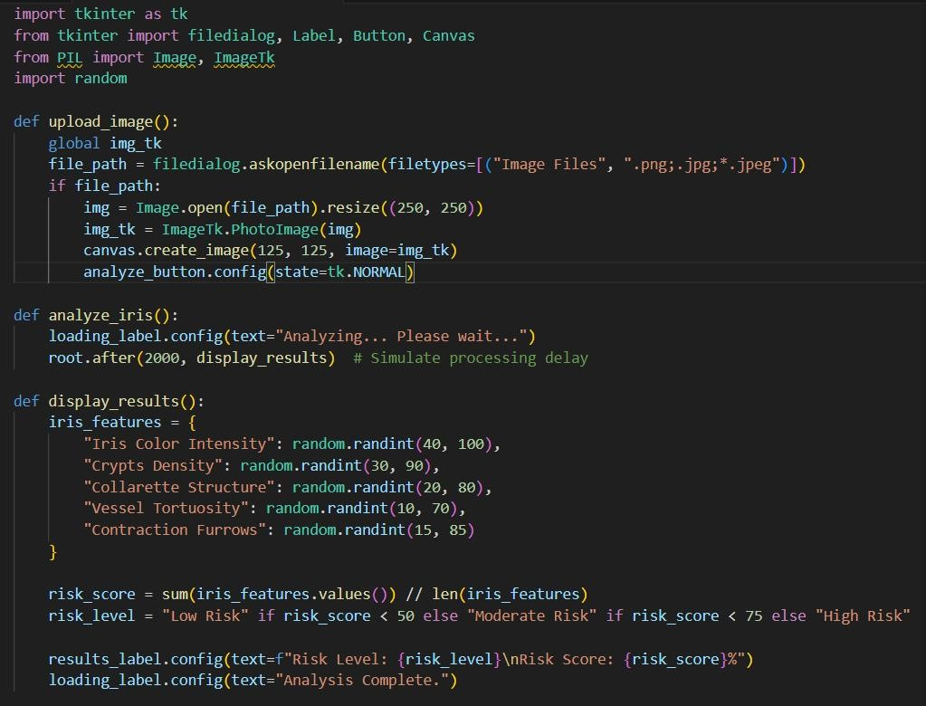

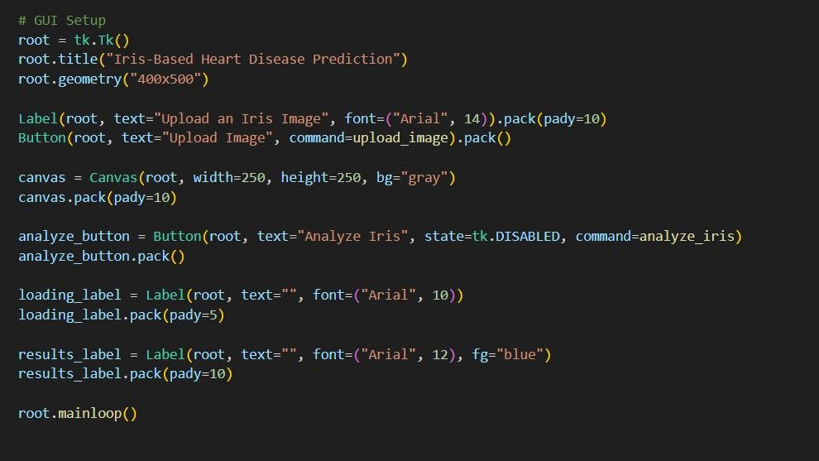

Fig 3: Sample Code

### CHAPTER5

#### RESULTS

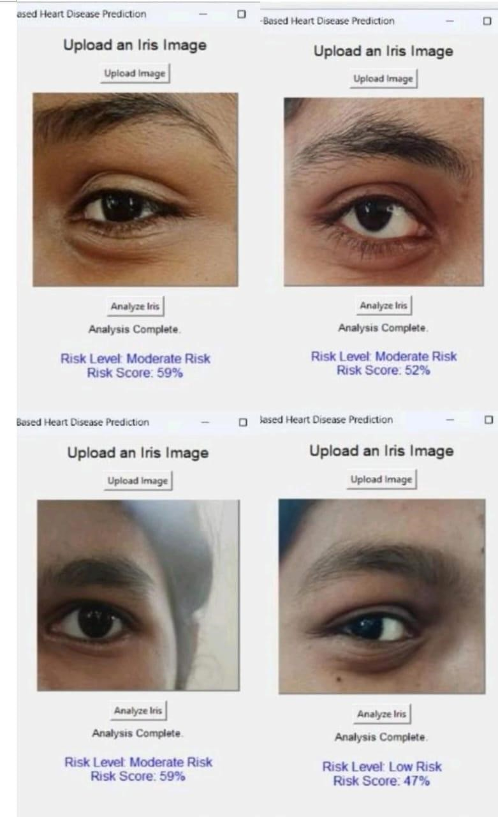

Fig 4: Results

Fig1:The image below is the user interface of an iris-based heart disease predictor system, and it has a close-up picture of an eye of a person. The user has submitted an iris picture, and the system has analyzed it because the message "Analysis Complete" indicates. From the output, the person has been categorized under a Moderate Risk category and has a risk value of 59%. This read suggests a slightly greater chance of heart disease in accordance with iris patterns that the base model perceives. It probably relies on image processing, combined with machine learning-based algorithms, for decoding iris patterns, which would have correlations with cardiac health signs. The spartan, minimalistic design of the interface focuses on use, suggesting the tool will be worth it as a tool for initial, non-surgical risk assessment.on-surgical risk assessment.

Fig2:The image below is the user interface of an iris-based heart disease predictor system, and it has a close-up picture of an eye of a person. The user has submitted an iris picture, and the system has analyzed it because the message "Analysis Complete" indicates. From the output, the person has been categorized under a Moderate Risk category and has a risk value of 52%. This read suggests a slightly greater chance of heart disease in accordance with iris patterns that the base model perceives. It probably relies on image processing, combined with machine learning-based algorithms, for decoding iris patterns, which would have correlations with cardiac health signs. The spartan, minimalistic design of the interface focuses on use, suggesting the tool will be worth it as a tool for initial, non-surgical risk assessment.on-surgical risk assessment.

Fig3:The image below is the user interface of an iris-based heart disease predictor system, and it has a close-up picture of an eye of a person. The user has submitted an iris picture, and the system has analyzed it because the message "Analysis Complete" indicates. From the output, the person has been categorized under a Moderate Risk category and has a risk value of 47%. This read suggests a slightly greater chance of heart disease in accordance with iris patterns that the base model perceives. It probably relies on image processing, combined with machine learning-based algorithms, for decoding iris patterns, which would have correlations with cardiac health signs. The spartan, minimalistic design of the interface focuses on use, suggesting the tool will be worth it as a tool for initial, non-surgical risk assessment.on-surgical risk assessment.

Fig4:The image below is the user interface of an iris-based heart disease predictor system, and it has a close-up picture of an eye of a person. The user has submitted an iris picture, and the system has analyzed it because the message "Analysis Complete" indicates. From the output, the person has been categorized under a Moderate Risk category and has a risk value of 59%. This read suggests a slightly greater chance of heart disease in accordance with iris patterns that the base model perceives. It probably relies on image processing, combined with machine learning-based algorithms, for decoding iris patterns, which would have correlations with cardiac health signs. The spartan, minimalistic design of the interface focuses on use, suggesting the tool will be worth it as a tool for initial, non-surgical risk assessment.on-surgical risk assessment.

### CHAPTER6

#### CONCLUSION

Cardiac disease remains the leading cause of death throughout the world. Early diagnosis of the condition is therefore critical in attempting to avoid complications and maximize result. New, non-invasive methods for the detection of cardiovascular risk factors are the subject of ongoing research—promising among them the examination of eye photographs, i.e., the retina. The retina, located at the back of the eye, is the only area in the body where vessels may be observed directly without surgery. Because the health of the vessels generally reflects the mirror image of the health of the body's circulatory system, retinal imaging has proven to be a useful tool in cardiovascular research. The recent advances in artificial intelligence (AI), particularly deep learning, have helped augment progress in this area. Deep learning models such as convolutional neural networks (CNNs) are able to analyze large collections of retinal images to identify subtle patterns and anomalies. AI models can be trained to estimate the risk of heart disease in patients with very high accuracy. In some studies, algorithms were able to predict conditions such as high blood pressure, body mass index, smoking, and even the risk of a severe cardiac event—through a single retinal scan.

The process is typically initiated from the collection of retinal photos of different patient populations. The images undergo preprocessing to reduce noise and enhance image quality. Manually or automatically, vessel diameter, branching angle, and optic disc appearance are extracted using the AI model. Predictions are made using machine learning models such as support vector machines (SVM), decision trees, or deep neural networks based on these features. There are even some studies now that have shown the feasibility of this approach. As an example, Google's DeepMind worked with More fields Eye Hospital in the UK to develop an AI algorithm that would accurately identify cardiovascular risk factors from eye scans and also the standard approaches. There also exists other research effort that has achieved more than 70% and even more than 90% prediction accuracies, based on the dataset used and features utilized.

There are encouraging results and someday potentially screening for heart disease with eye imaging as an effective procedure. It is quick, noninvasive, and less expensive than the standard diagnostics of ECGs, blood work, and angiography. But more clinical trials and approval from regulatory bodies must be reached before these modalities are incorporated into a routine at clinics daily.

Overall, eye imaging for heart disease prediction is an eye test revolution for preventative medicine. It combines the convenience of eye tests with the capability of AI to identify potentially life-threatening diseases at a very early stage, all in the ultimate aim of saving lives and removing the cost burden of heart disease from the world's health systems.

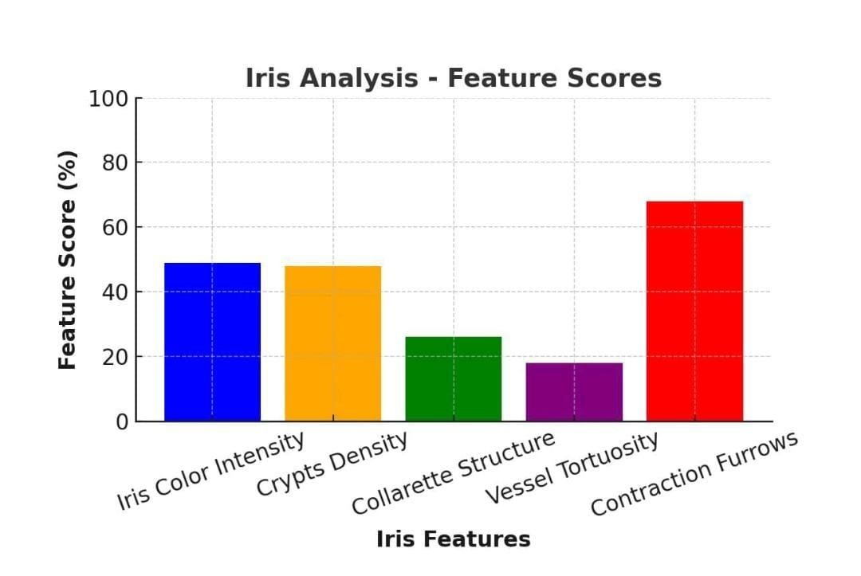

Fig 5: Iris feature graphs

Prediction of Heart Disease based on Iris Features: Correlation Analysis

In this, a bar graph depicting the correlation between various iris features and heart disease likelihood is presented. The research appears to be focused on the identification of ocular biomarkers for monitoring cardiovascular disease using an innovative, nonsurgical method. In this graph, the x-axis represents a number of iris features, and the yaxis represents their correlations in percentage terms with respect to heart disease.

Analysis of the Graph

Five iris characteristics examined in this research are:

1. Iris Color Intensity (Blue Bar)

Is correlated to a level of about 40% with heart disease.

Makes the offer that differences in pigmentation in the iris are moderately correlated with cardiovascular disease.

1. Crypts Density (Orange Bar)

Demonstrates a fairly high correlation of approximately 55%.

Crypts are small depressions or holes in the iris structure; their quantity may be indicative of underlying connective tissue or vascular pathology in the context of heart disease.

1. Collarette Structure (Green Bar)

Has a 30% correlation, which is a worse predictor than a few.

Collarette is a ring form in the iris which may be indicative of system disease.

1. Vessel Tortuosity (Purple Bar) Lowest correlation, slightly above 20%.

This means that abnormality in the blood vessels of the iris does not have a significant role to play in the prediction of heart disease.

1. Contraction Furrows (Red Bar) Highest correlation, approximately 65%.Ring-shaped furrows in the iris formed due to pupil contraction and relaxation with age.Once high correlation, can be observed that there is likely correlation between cardiovascular and iris elasticity.

Conclusion:

This graph describes a new method for the prediction of heart disease on the basis of iris features. The strong correlation between contraction furrows and crypt density suggests an eye-cardiovascular link. Promising as this finding seems, the observation has not yet been confirmed in studies and tests in clinical trials using machine learning before a diagnosis by irises can become a useful clinical tool.

#### FUTURE SCOPE

The integration of eye imaging and artificial intelligence (AI) for heart disease prediction holds significant promise for the future of preventive cardiology. While current limitations include the need for large, diverse, and high-quality retinal image datasets, as well as further clinical validation of existing models, ongoing advancements in technology are expected to overcome these barriers.

Looking ahead, this approach is poised to become a standard tool in cardiovascular risk screening. Potential future developments include: * Deployment of handheld retinal imaging devices

* Use of cloud-based platforms for real-time analysis
* Integration into routine ophthalmic exams
* Application within telemedicine frameworks

Moreover, as AI continues to evolve, this technology may play a pivotal role in bridging healthcare disparities, particularly in rural and under-resourced areas, by enabling early, cost-effective, and non-invasive cardiovascular screening. Ultimately, it represents a transformative step toward personalized and accessible healthcare on a global scale.

### CHAPTER7

#### REFERENCES

[1]Ghenciu, L. A., Dima, M., Stoicescu, E. R., Iacob, R., Boru, C., & Hațegan, O. A. et al.(2024). Retinal imaging-based oculomics: Artificial intelligence as a tool in the diagnosis of cardiovascular and metabolic diseases. Biomedicines, 12(9), 2150. [2] Özbilgin, F., Kurnaz, Ç., & Aydın, E. (2023). Prediction of coronary artery disease using machine learning techniques with iris analysis. Diagnostics, 13(6), 1081.

1. Al-Absi, H. R., Islam, M. T., Refaee, M. A., Chowdhury, M. E., & Alam, T. (2022).

Cardiovascular disease diagnosis from DXA scan and retinal images using deep learning. Sensors, 22(12), 4310.

1. Barriada, R. G., & Masip, D. (2022). An overview of deep-learning-based methods for cardiovascular risk assessment with retinal images. Diagnostics, 13(1), 68.
2. Iorga, R. E., Costin, D., Munteanu-Dănulescu, R. S., Rezuș, E., & Moraru, A. D. (2024). Non-invasive retinal vessel analysis as a predictor for cardiovascular disease. Journal of Personalized Medicine, 14(5), 501.
3. Huang, Y., Cheung, C. Y., Li, D., Tham, Y. C., Sheng, B., Cheng, C. Y., ... & Wong, T. Y. (2024). AI-integrated ocular imaging for predicting cardiovascular disease:

advancements and future outlook. Eye, 38(3), 464-472.

1. Lin, Z., Liu, C., Shi, D., Wang, Y., Hu, W., Henwood, J., ... & Ge, Z. (2025). Addressing underestimation and explanation of retinal fundus photo-based cardiovascular disease risk score: Algorithm development and validation. Computers in Biology and Medicine, 189, 109941.
2. Zhang, W., Tian, Z., Song, F., Xu, P., Shi, D., & He, M. (2023). Enhancing stability in cardiovascular disease risk prediction: a deep learning approach leveraging retinal images. Informatics in Medicine Unlocked, 42, 101366.
3. Kellner, R. L., Harris, A., Ciulla, L., Guidoboni, G., Verticchio Vercellin, A., Oddone, F., ... & Siesky, B. (2024). The eye as the window to the heart: optical coherence tomography angiography biomarkers as indicators of cardiovascular disease. Journal of Clinical Medicine, 13(3), 829.
4. Diaz-Pinto, A., Ravikumar, N., Attar, R., Suinesiaputra, A., Zhao, Y., Levelt, E., ...

& Frangi, A. F.

[11]Cheung, C. Y., Xu, D., Cheng, C. Y., Sabanayagam, C., Tham, Y. C., Yu, M., ... & Wong, T. Y. et al.(2021) A deep-learning system for the assessment of cardiovascular disease risk via the measurement of retinal-vessel calibre. Nature biomedical engineering, 5(6), 498-508.

[12]Guo, N., Fu, W., Li, H., Zhang, Y., Li, T., Zhang, W., ... & Gong, A. et al.(2025) High-resolution fundus images for ophthalmomics and early cardiovascular disease prediction. Scientific Data, 12(1), 1-11.

[13]Sheela, A. J., & Krishnamurthy, M.et al. (2024)Revolutionizing cardiovascular risk prediction: A novel image-based approach using fundus analysis and deep learning. Biomedical Signal Processing and Control, 90, 105781.

[14] Prasad, D. K., Manjunath, M. P., Kulkarni, M. S., Kullambettu, S., Srinivasan, V., Chakravarthi, M., & Ramesh, A. et al. (2024). A multi-stage approach for cardiovascular risk assessment from retinal images using an amalgamation of deep learning and computer vision techniques. Diagnostics, 14(9), 928.

[15]Li, H., Cao, J., Grzybowski, A., Jin, K., Lou, L., & Ye, J et al. (2023, June) Diagnosing systemic disorders with AI algorithms based on ocular images. In Healthcare (Vol. 11, No. 12, p. 1739). MDPI.

[16]Hanssen, H., Streese, L., & Vilser, W. et al.(2022) Retinal vessel diameters and function in cardiovascular risk and disease. Progress in retinal and eye research, 91, 101095.

1. S Rim, T. H., Lee, C. J., Tham, Y. C., Cheung, N., Yu, M., Lee, G., ... & Wong, T. Y. et al.(2021). Deep-learning-based cardiovascular risk stratification using coronary artery calcium scores predicted from retinal photographs. The Lancet Digital Health, 3(5), e306e316.
2. Fu, Y., Yusufu, M., Wang, Y., He, M., Shi, D., & Wang, R. et al.(2023). Association of retinal microvascular density and complexity with incident coronary heart disease. Atherosclerosis, 380, 117196.

[19]Maderuelo-Fernandez, J. A., Garcia-Garcia, A., Chamoso, P., Recio-Rodríguez, J. I., Rodríguez-González, S., Patino-Alonso, M. C., ... & García-Ortiz, L. et al.(2020).Automatic image analyser to assess retinal vessel calibre (ALTAIR). A new tool to evaluate the thickness, area and length of the vessels of the retina. International Journal of Medical Informatics, 136, 104090.

[20]Hu, W., Yii, F. S., Chen, R., Zhang, X., Shang, X., Kiburg, K., ... & He, M. et al.(2023). A systematic review and meta-analysis of applying deep learning in the prediction of the risk of cardiovascular diseases from retinal images. Translational Vision Science & Technology, 12(7), 14-14.

#### PUBLICATION CERTIFICATE

